Öğrenci No: G201210029

Öğrenci Adı Soyadı: Umut Can ÇAĞATAY

e-posta: [umut.cagatay@ogr.sakarya.edu.tr](mailto:umut.cagatay@ogr.sakarya.edu.tr)

Tanıtım: Uygulama bir müzik çalara yazılıma ait veri tabanında çalma listelerine müzik ekleme, çıkarma, müzik arama, çalma listelerini yönetme işlemlerini gerçekleştiriyor.

İş Kuralları:

* Kullanıcıların kullanıcı adı, e-mail, şifre, oluşturulma tarihi bilgileri mevcuttur.
* Kullanıcılar dinleyici ve sanatçı olmak üzere ikiye ayrılır.
* Sanatçının isim bilgisi mevcuttur.
* Albümlerin kodu, ismi, çıkaran sanatçısı, çıkış tarihi, şarkı adeti bilgileri tutulmalıdır.
* Albümler sanatçılar tarafından çıkarılmaktadır.
* Podcastlerin kodu, ismi, çıkaran sanatçısı, çıkış tarihi, şarkı adeti bilgileri tutulmalıdır.
* Podcastler sanatçılar tarafından çıkarılmaktadır.
* Şarkıların kodu, isim, tür bilgisi tutulmalıdır.
* Şarkı türü kodu, tür bilgilerini tutmalıdır.
* Bölümlerin kodu, ismi, tür bilgisi tutulmalıdır.
* Bölüm türü kodu, tür bilgileri tutmalıdır.
* Dinleyicinin kullanıcı adı, isim, kitaplık, dinlenen şarkı sayısı bilgileri mevcuttur.
* Kitaplık kodu, dinleyici kullanıcı adı, çalma listesi sayısı tutulmalıdır.
* Kitaplık dinleyiciye özeldir. Sadece tek dinleyiciye ait olabilir.
* Çalma listesi kodu, ismi, oluşturulma tarihi, oluşturan dinleyici, şarkı adeti bilgileri tutulmalıdır.
* Sanatçı ve dinleyici arasındaki bağlantı kullanıcı adı ile kurulur.
* Bir kullanıcı ya dinleyici ya da sanatçı olmak zorundadır. İkisi birden olamaz.
* Bir sanatçı hiç albüme sahip olamayacağı gibi birden fazlasına da sahip olabilir. Bir albüm yalnızca bir sanatçıya ait olabilir.
* Bir sanatçı hiç podcast sahip olamayacağı gibi birden fazlasına da sahip olabilir. Bir podcast yalnızca bir sanatçıya ait olabilir.
* Bir sanatçının ismi benzersiz olmalıdır.
* Bir albüm çok sayıda şarkıdan oluşur. En az bir şarkıdan oluşmak zorundadır.
* Bir podcast çok sayıda bölümden oluşur. En az bir bölümden oluşmak zorundadır.
* Bir şarkı bir albüme ait olmak zorundadır. Bu bilgiler kayıt altına alınmalıdır. Bir şarkı yalnızca bir albüme ait olabilir.
* Bir şarkı bir şarkı türüne ait olmak zorundadır. Bir tür birden fazla şarkıya ait olabileceği gibi hiç ait olmayabilir.
* Bir bölüm yalnızca bir podcaste aittir. Bu bilgi kayıt altına alınmalıdır.
* Bir bölüm yalnızca bir podcast türüne ait olabilir.
* Dinleyiciler yalnızca bir kitaplığa sahip olabilir. Bir kitaplık yalnızca bir dinleyiciye ait olabilir.
* Bir kitaplık birden fazla çalma listesi içerebileceği gibi, hiç içermeyebilir.
* Bir çalma listesi kitaplıklara ait olabildiği gibi hiç ait olmayabilir.
* Çalma listelerinin ait oldukları kitaplık bilgileri tutulmalıdır.
* Bir çalma listesi birden fazla şarkı içerebileceği gibi hiç şarkı içermeyebilir.
* Bir şarkı birden fazla çalma listesine ait olabileceği gibi hiç çalma listesine ait olmayabilir.
* Çalma listelerindeki şarkıların bilgileri tutulmalıdır.
* Bir sanatçıyı birden fazla dinleyici takip edebilir ancak bir sanatçı bir kullanıcıyı takip edemez.
* Bir dinleyici birden fazla dinleyici veya sanatçı takip edebildiği gibi hiç takip etmeyebilirde.

İlişkisel Şema:

* Profile(id: serial, username: string, e-mail: string, password: integer, createdAt: date)
* Artist(id: serial, name: string)
* Listener(id: serial, name: string, listenedSongAmount: integer)
* Album(id: serial, name: string, artist: integer, createdAt: date, songAmount: integer)
* Podcast(id: serial, name: string, artist: integer, createdAt: date, songAmount: integer)
* PodcastEpisode(podcastID: integer, episodeID: integer)
* Episode(id: serial, name: string, category: integer)
* EpisodeCategory(id: serial, name: string)
* AlbumSong(albumID: integer, songID: integer)
* Song(id: serial, name: string, category: integer)
* SongCategory(id: serial, name: string)
* ArtistFollower(artistID: integer, listenerID: integer)
* Follows(followerID: integer, followedID: integer)
* Library(id: serial, listenerID: integer, playlistAmount: integer)
* LibraryPlaylist(libraryID: integer, playlistID: integer)
* Playlist(id: serial, name: string, createdAt: date, creater: integer, songAmount: integer)
* PlaylistSong(playlistID: integer, songID: integer)

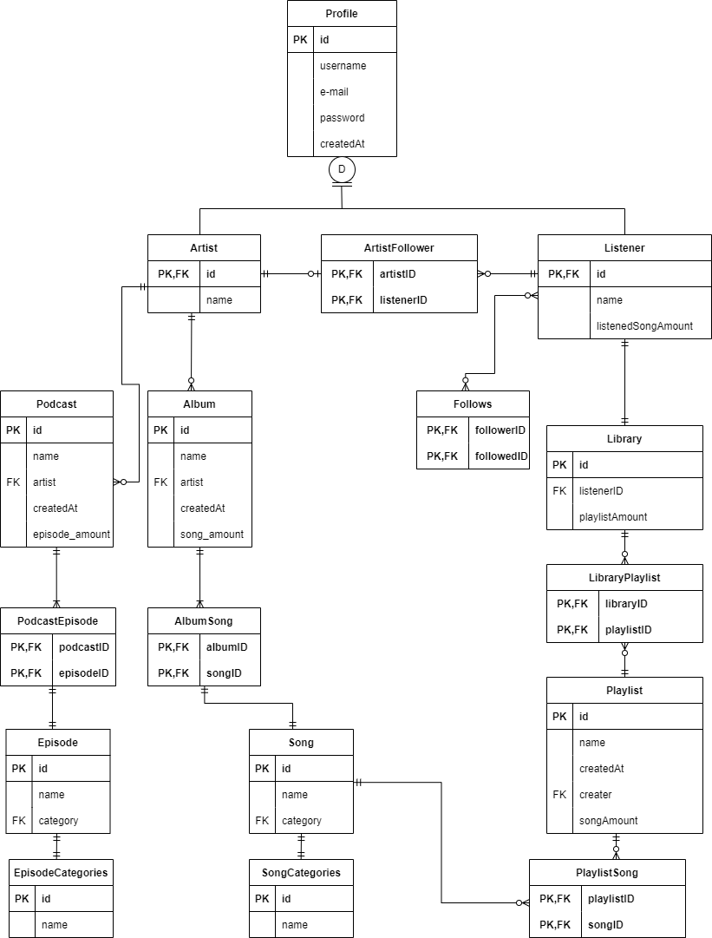

--

-- PostgreSQL database dump

--

-- Dumped from database version 15.1

-- Dumped by pg_dump version 15.1

-- Started on 2022-12-26 16:55:42

SET statement_timeout = 0;

SET lock_timeout = 0;

SET idle_in_transaction_session_timeout = 0;

SET client_encoding = 'UTF8';

SET standard_conforming_strings = on;

SELECT pg_catalog.set_config('search_path', '', false);

SET check_function_bodies = false;

SET xmloption = content;

SET client_min_messages = warning;

SET row_security = off;

--

-- TOC entry 240 (class 1255 OID 17493)

-- Name: add_library_func(); Type: FUNCTION; Schema: public; Owner: postgres

--

CREATE FUNCTION public.add_library_func() RETURNS trigger

    LANGUAGE plpgsql

    AS $$

begin

    Insert into library values (default, new.id, default);

    return new;

end;

$$;

ALTER FUNCTION public.add_library_func() OWNER TO postgres;

--

-- TOC entry 244 (class 1255 OID 17530)

-- Name: add_song(integer, integer); Type: PROCEDURE; Schema: public; Owner: postgres

--

CREATE PROCEDURE public.add_song(IN p1 integer, IN p2 integer)

    LANGUAGE plpgsql

    AS $$

begin

insert into playlist_song values (p1, p2);

end; $$;

ALTER PROCEDURE public.add_song(IN p1 integer, IN p2 integer) OWNER TO postgres;

--

-- TOC entry 261 (class 1255 OID 17540)

-- Name: change_playlist_name(text, integer); Type: PROCEDURE; Schema: public; Owner: postgres

--

CREATE PROCEDURE public.change_playlist_name(IN p1 text, IN p2 integer)

    LANGUAGE plpgsql

    AS $$

begin

update playlist set name = p1 where id = p2;

end; $$;

ALTER PROCEDURE public.change_playlist_name(IN p1 text, IN p2 integer) OWNER TO postgres;

--

-- TOC entry 242 (class 1255 OID 17521)

-- Name: decrease_song_amount_func(); Type: FUNCTION; Schema: public; Owner: postgres

--

CREATE FUNCTION public.decrease_song_amount_func() RETURNS trigger

    LANGUAGE plpgsql

    AS $$

begin

    update playlist set song_amount = song_amount - 1 where id = old.playlist_id;

    return new;

end;

$$;

ALTER FUNCTION public.decrease_song_amount_func() OWNER TO postgres;

--

-- TOC entry 245 (class 1255 OID 17531)

-- Name: delete_song(integer, integer); Type: PROCEDURE; Schema: public; Owner: postgres

--

CREATE PROCEDURE public.delete_song(IN p1 integer, IN p2 integer)

    LANGUAGE plpgsql

    AS $$

begin

delete from playlist_song where playlist_id = p1 and song_id = p2;

end; $$;

ALTER PROCEDURE public.delete_song(IN p1 integer, IN p2 integer) OWNER TO postgres;

--

-- TOC entry 260 (class 1255 OID 17539)

-- Name: find_song(text); Type: FUNCTION; Schema: public; Owner: postgres

--

CREATE FUNCTION public.find_song(p1 text) RETURNS TABLE(songid integer, songname character varying, artist character varying, album character varying)

    LANGUAGE plpgsql

    AS $$

begin

    return query

    select song.id, song.name, artist.name, album.name from album_song

    inner join album

    on album_song.album_id = album.id

    inner join song

    on album_song.song_id = song.id

    inner join artist

    on album.artist = artist.id

    where song.name = p1;

end;

$$;

ALTER FUNCTION public.find_song(p1 text) OWNER TO postgres;

--

-- TOC entry 252 (class 1255 OID 17536)

-- Name: find_song(character varying); Type: FUNCTION; Schema: public; Owner: postgres

--

CREATE FUNCTION public.find_song(p1 character varying) RETURNS TABLE(songid integer, songname character varying, artist character varying, album character varying)

    LANGUAGE plpgsql

    AS $$

begin

    return query

    select song.id, song.name, artist.name, album.name from album_song

    inner join album

    on album_song.album_id = album.id

    inner join song

    on album_song.song_id = song.id

    inner join artist

    on album.artist = artist.id

    where song.name = p1;

end;

$$;

ALTER FUNCTION public.find_song(p1 character varying) OWNER TO postgres;

--

-- TOC entry 243 (class 1255 OID 17523)

-- Name: increase_playlist_amount_func(); Type: FUNCTION; Schema: public; Owner: postgres

--

CREATE FUNCTION public.increase_playlist_amount_func() RETURNS trigger

    LANGUAGE plpgsql

    AS $$

begin

    update library set playlist_amount = playlist_amount + 1 where id = new.library_id;

    return new;

end;

$$;

ALTER FUNCTION public.increase_playlist_amount_func() OWNER TO postgres;

--

-- TOC entry 241 (class 1255 OID 17519)

-- Name: increase_song_amount_func(); Type: FUNCTION; Schema: public; Owner: postgres

--

CREATE FUNCTION public.increase_song_amount_func() RETURNS trigger

    LANGUAGE plpgsql

    AS $$

begin

    update playlist set song_amount = song_amount + 1 where id = new.playlist_id;

    return new;

end;

$$;

ALTER FUNCTION public.increase_song_amount_func() OWNER TO postgres;

--

-- TOC entry 246 (class 1255 OID 17532)

-- Name: playlist_list(); Type: FUNCTION; Schema: public; Owner: postgres

--

CREATE FUNCTION public.playlist_list() RETURNS TABLE(playlistid integer, playlistadi character varying, sarkiid integer, sarkiadi character varying)

    LANGUAGE plpgsql

    AS $$

begin

    return query

    select playlist.id, playlist.name, song.id, song.name from playlist_song

    inner join playlist

    on playlist_song.playlist_id = playlist.id

    inner join song

    on playlist_song.song_id = song.id ORDER BY playlist_id ASC, song_id ASC;

end;

$$;

ALTER FUNCTION public.playlist_list() OWNER TO postgres;

--

-- TOC entry 247 (class 1255 OID 17533)

-- Name: song_list(); Type: FUNCTION; Schema: public; Owner: postgres

--

CREATE FUNCTION public.song_list() RETURNS TABLE(songid integer, songname character varying, artist character varying, album character varying)

    LANGUAGE plpgsql

    AS $$

begin

    return query

    select song.id, song.name, artist.name, album.name from album_song

    inner join album

    on album_song.album_id = album.id

    inner join song

    on album_song.song_id = song.id

    inner join artist

    on album.artist = artist.id

    ORDER BY album_id ASC, song_id ASC;

end;

$$;

ALTER FUNCTION public.song_list() OWNER TO postgres;

SET default_tablespace = '';

SET default_table_access_method = heap;

--

-- TOC entry 223 (class 1259 OID 17247)

-- Name: album; Type: TABLE; Schema: public; Owner: postgres

--

CREATE TABLE public.album (

    id integer NOT NULL,

    name character varying(50) NOT NULL,

    artist integer NOT NULL,

    created_at date DEFAULT CURRENT_DATE NOT NULL,

    song_amount integer DEFAULT 0

);

ALTER TABLE public.album OWNER TO postgres;

--

-- TOC entry 222 (class 1259 OID 17246)

-- Name: album_id_seq; Type: SEQUENCE; Schema: public; Owner: postgres

--

CREATE SEQUENCE public.album_id_seq

    AS integer

    START WITH 1

    INCREMENT BY 1

    NO MINVALUE

    NO MAXVALUE

    CACHE 1;

ALTER TABLE public.album_id_seq OWNER TO postgres;

--

-- TOC entry 3513 (class 0 OID 0)

-- Dependencies: 222

-- Name: album_id_seq; Type: SEQUENCE OWNED BY; Schema: public; Owner: postgres

--

ALTER SEQUENCE public.album_id_seq OWNED BY public.album.id;

--

-- TOC entry 233 (class 1259 OID 17351)

-- Name: album_song; Type: TABLE; Schema: public; Owner: postgres

--

CREATE TABLE public.album_song (

    album_id integer NOT NULL,

    song_id integer NOT NULL

);

ALTER TABLE public.album_song OWNER TO postgres;

--

-- TOC entry 215 (class 1259 OID 17170)

-- Name: profile; Type: TABLE; Schema: public; Owner: postgres

--

CREATE TABLE public.profile (

    id integer NOT NULL,

    username character varying(100) NOT NULL,

    email character varying(50) NOT NULL,

    password integer NOT NULL,

    created_at date DEFAULT CURRENT_DATE

);

ALTER TABLE public.profile OWNER TO postgres;

--

-- TOC entry 216 (class 1259 OID 17183)

-- Name: artist; Type: TABLE; Schema: public; Owner: postgres

--

CREATE TABLE public.artist (

    name character varying(100) NOT NULL

)

INHERITS (public.profile);

ALTER TABLE public.artist OWNER TO postgres;

--

-- TOC entry 237 (class 1259 OID 17412)

-- Name: artist_followers; Type: TABLE; Schema: public; Owner: postgres

--

CREATE TABLE public.artist_followers (

    artist_id integer NOT NULL,

    follower_id integer NOT NULL

);

ALTER TABLE public.artist_followers OWNER TO postgres;

--

-- TOC entry 225 (class 1259 OID 17279)

-- Name: episode; Type: TABLE; Schema: public; Owner: postgres

--

CREATE TABLE public.episode (

    id integer NOT NULL,

    name character varying(50) NOT NULL,

    category integer NOT NULL

);

ALTER TABLE public.episode OWNER TO postgres;

--

-- TOC entry 227 (class 1259 OID 17288)

-- Name: episode_category; Type: TABLE; Schema: public; Owner: postgres

--

CREATE TABLE public.episode_category (

    id integer NOT NULL,

    name character varying(50) NOT NULL

);

ALTER TABLE public.episode_category OWNER TO postgres;

--

-- TOC entry 226 (class 1259 OID 17287)

-- Name: episode_category_id_seq; Type: SEQUENCE; Schema: public; Owner: postgres

--

CREATE SEQUENCE public.episode_category_id_seq

    AS integer

    START WITH 1

    INCREMENT BY 1

    NO MINVALUE

    NO MAXVALUE

    CACHE 1;

ALTER TABLE public.episode_category_id_seq OWNER TO postgres;

--

-- TOC entry 3514 (class 0 OID 0)

-- Dependencies: 226

-- Name: episode_category_id_seq; Type: SEQUENCE OWNED BY; Schema: public; Owner: postgres

--

ALTER SEQUENCE public.episode_category_id_seq OWNED BY public.episode_category.id;

--

-- TOC entry 224 (class 1259 OID 17278)

-- Name: episode_id_seq; Type: SEQUENCE; Schema: public; Owner: postgres

--

CREATE SEQUENCE public.episode_id_seq

    AS integer

    START WITH 1

    INCREMENT BY 1

    NO MINVALUE

    NO MAXVALUE

    CACHE 1;

ALTER TABLE public.episode_id_seq OWNER TO postgres;

--

-- TOC entry 3515 (class 0 OID 0)

-- Dependencies: 224

-- Name: episode_id_seq; Type: SEQUENCE OWNED BY; Schema: public; Owner: postgres

--

ALTER SEQUENCE public.episode_id_seq OWNED BY public.episode.id;

--

-- TOC entry 238 (class 1259 OID 17427)

-- Name: follows; Type: TABLE; Schema: public; Owner: postgres

--

CREATE TABLE public.follows (

    follower_id integer NOT NULL,

    followed_id integer NOT NULL

);

ALTER TABLE public.follows OWNER TO postgres;

--

-- TOC entry 219 (class 1259 OID 17218)

-- Name: library; Type: TABLE; Schema: public; Owner: postgres

--

CREATE TABLE public.library (

    id integer NOT NULL,

    listener_id integer DEFAULT 0 NOT NULL,

    playlist_amount integer DEFAULT 0 NOT NULL

);

ALTER TABLE public.library OWNER TO postgres;

--

-- TOC entry 218 (class 1259 OID 17217)

-- Name: library_id_seq; Type: SEQUENCE; Schema: public; Owner: postgres

--

CREATE SEQUENCE public.library_id_seq

    AS integer

    START WITH 1

    INCREMENT BY 1

    NO MINVALUE

    NO MAXVALUE

    CACHE 1;

ALTER TABLE public.library_id_seq OWNER TO postgres;

--

-- TOC entry 3516 (class 0 OID 0)

-- Dependencies: 218

-- Name: library_id_seq; Type: SEQUENCE OWNED BY; Schema: public; Owner: postgres

--

ALTER SEQUENCE public.library_id_seq OWNED BY public.library.id;

--

-- TOC entry 236 (class 1259 OID 17397)

-- Name: library_playlist; Type: TABLE; Schema: public; Owner: postgres

--

CREATE TABLE public.library_playlist (

    library_id integer NOT NULL,

    playlist_id integer NOT NULL

);

ALTER TABLE public.library_playlist OWNER TO postgres;

--

-- TOC entry 217 (class 1259 OID 17205)

-- Name: listener; Type: TABLE; Schema: public; Owner: postgres

--

CREATE TABLE public.listener (

    name character varying(100) NOT NULL,

    listened_song_amount integer DEFAULT 0 NOT NULL

)

INHERITS (public.profile);

ALTER TABLE public.listener OWNER TO postgres;

--

-- TOC entry 235 (class 1259 OID 17382)

-- Name: playlist; Type: TABLE; Schema: public; Owner: postgres

--

CREATE TABLE public.playlist (

    id integer NOT NULL,

    name character varying NOT NULL,

    created_at date DEFAULT CURRENT_DATE NOT NULL,

    creater integer NOT NULL,

    song_amount integer DEFAULT 0 NOT NULL

);

ALTER TABLE public.playlist OWNER TO postgres;

--

-- TOC entry 234 (class 1259 OID 17381)

-- Name: playlist_id_seq; Type: SEQUENCE; Schema: public; Owner: postgres

--

CREATE SEQUENCE public.playlist_id_seq

    AS integer

    START WITH 1

    INCREMENT BY 1

    NO MINVALUE

    NO MAXVALUE

    CACHE 1;

ALTER TABLE public.playlist_id_seq OWNER TO postgres;

--

-- TOC entry 3517 (class 0 OID 0)

-- Dependencies: 234

-- Name: playlist_id_seq; Type: SEQUENCE OWNED BY; Schema: public; Owner: postgres

--

ALTER SEQUENCE public.playlist_id_seq OWNED BY public.playlist.id;

--

-- TOC entry 239 (class 1259 OID 17458)

-- Name: playlist_song; Type: TABLE; Schema: public; Owner: postgres

--

CREATE TABLE public.playlist_song (

    playlist_id integer NOT NULL,

    song_id integer NOT NULL

);

ALTER TABLE public.playlist_song OWNER TO postgres;

--

-- TOC entry 221 (class 1259 OID 17231)

-- Name: podcast; Type: TABLE; Schema: public; Owner: postgres

--

CREATE TABLE public.podcast (

    id integer NOT NULL,

    name character varying(50) NOT NULL,

    artist integer NOT NULL,

    created_at date DEFAULT CURRENT_DATE NOT NULL,

    episode_amount integer DEFAULT 0

);

ALTER TABLE public.podcast OWNER TO postgres;

--

-- TOC entry 228 (class 1259 OID 17296)

-- Name: podcast_episode; Type: TABLE; Schema: public; Owner: postgres

--

CREATE TABLE public.podcast_episode (

    podcast_id integer NOT NULL,

    episode_id integer NOT NULL

);

ALTER TABLE public.podcast_episode OWNER TO postgres;

--

-- TOC entry 220 (class 1259 OID 17230)

-- Name: podcast_id_seq; Type: SEQUENCE; Schema: public; Owner: postgres

--

CREATE SEQUENCE public.podcast_id_seq

    AS integer

    START WITH 1

    INCREMENT BY 1

    NO MINVALUE

    NO MAXVALUE

    CACHE 1;

ALTER TABLE public.podcast_id_seq OWNER TO postgres;

--

-- TOC entry 3518 (class 0 OID 0)

-- Dependencies: 220

-- Name: podcast_id_seq; Type: SEQUENCE OWNED BY; Schema: public; Owner: postgres

--

ALTER SEQUENCE public.podcast_id_seq OWNED BY public.podcast.id;

--

-- TOC entry 214 (class 1259 OID 17169)

-- Name: profile_id_seq; Type: SEQUENCE; Schema: public; Owner: postgres

--

CREATE SEQUENCE public.profile_id_seq

    AS integer

    START WITH 1

    INCREMENT BY 1

    NO MINVALUE

    NO MAXVALUE

    CACHE 1;

ALTER TABLE public.profile_id_seq OWNER TO postgres;

--

-- TOC entry 3519 (class 0 OID 0)

-- Dependencies: 214

-- Name: profile_id_seq; Type: SEQUENCE OWNED BY; Schema: public; Owner: postgres

--

ALTER SEQUENCE public.profile_id_seq OWNED BY public.profile.id;

--

-- TOC entry 229 (class 1259 OID 17311)

-- Name: song_id_seq; Type: SEQUENCE; Schema: public; Owner: postgres

--

CREATE SEQUENCE public.song_id_seq

    AS integer

    START WITH 1

    INCREMENT BY 1

    NO MINVALUE

    NO MAXVALUE

    CACHE 1;

ALTER TABLE public.song_id_seq OWNER TO postgres;

--

-- TOC entry 230 (class 1259 OID 17312)

-- Name: song; Type: TABLE; Schema: public; Owner: postgres

--

CREATE TABLE public.song (

    id integer DEFAULT nextval('public.song_id_seq'::regclass) NOT NULL,

    name character varying(50) NOT NULL,

    category integer NOT NULL

);

ALTER TABLE public.song OWNER TO postgres;

--

-- TOC entry 232 (class 1259 OID 17340)

-- Name: song_category; Type: TABLE; Schema: public; Owner: postgres

--

CREATE TABLE public.song_category (

    id integer NOT NULL,

    name character varying(50) NOT NULL

);

ALTER TABLE public.song_category OWNER TO postgres;

--

-- TOC entry 231 (class 1259 OID 17339)

-- Name: song_category_id_seq; Type: SEQUENCE; Schema: public; Owner: postgres

--

CREATE SEQUENCE public.song_category_id_seq

    AS integer

    START WITH 1

    INCREMENT BY 1

    NO MINVALUE

    NO MAXVALUE

    CACHE 1;

ALTER TABLE public.song_category_id_seq OWNER TO postgres;

--

-- TOC entry 3520 (class 0 OID 0)

-- Dependencies: 231

-- Name: song_category_id_seq; Type: SEQUENCE OWNED BY; Schema: public; Owner: postgres

--

ALTER SEQUENCE public.song_category_id_seq OWNED BY public.song_category.id;

--

-- TOC entry 3269 (class 2604 OID 17250)

-- Name: album id; Type: DEFAULT; Schema: public; Owner: postgres

--

ALTER TABLE ONLY public.album ALTER COLUMN id SET DEFAULT nextval('public.album_id_seq'::regclass);

--

-- TOC entry 3258 (class 2604 OID 17186)

-- Name: artist id; Type: DEFAULT; Schema: public; Owner: postgres

--

ALTER TABLE ONLY public.artist ALTER COLUMN id SET DEFAULT nextval('public.profile_id_seq'::regclass);

--

-- TOC entry 3259 (class 2604 OID 17204)

-- Name: artist created_at; Type: DEFAULT; Schema: public; Owner: postgres

--

ALTER TABLE ONLY public.artist ALTER COLUMN created_at SET DEFAULT CURRENT_DATE;

--

-- TOC entry 3272 (class 2604 OID 17282)

-- Name: episode id; Type: DEFAULT; Schema: public; Owner: postgres

--

ALTER TABLE ONLY public.episode ALTER COLUMN id SET DEFAULT nextval('public.episode_id_seq'::regclass);

--

-- TOC entry 3273 (class 2604 OID 17291)

-- Name: episode_category id; Type: DEFAULT; Schema: public; Owner: postgres

--

ALTER TABLE ONLY public.episode_category ALTER COLUMN id SET DEFAULT nextval('public.episode_category_id_seq'::regclass);

--

-- TOC entry 3263 (class 2604 OID 17221)

-- Name: library id; Type: DEFAULT; Schema: public; Owner: postgres

--

ALTER TABLE ONLY public.library ALTER COLUMN id SET DEFAULT nextval('public.library_id_seq'::regclass);

--

-- TOC entry 3260 (class 2604 OID 17208)

-- Name: listener id; Type: DEFAULT; Schema: public; Owner: postgres

--

ALTER TABLE ONLY public.listener ALTER COLUMN id SET DEFAULT nextval('public.profile_id_seq'::regclass);

--

-- TOC entry 3261 (class 2604 OID 17209)

-- Name: listener created_at; Type: DEFAULT; Schema: public; Owner: postgres

--

ALTER TABLE ONLY public.listener ALTER COLUMN created_at SET DEFAULT CURRENT_DATE;

--

-- TOC entry 3276 (class 2604 OID 17385)

-- Name: playlist id; Type: DEFAULT; Schema: public; Owner: postgres

--

ALTER TABLE ONLY public.playlist ALTER COLUMN id SET DEFAULT nextval('public.playlist_id_seq'::regclass);

--

-- TOC entry 3266 (class 2604 OID 17234)

-- Name: podcast id; Type: DEFAULT; Schema: public; Owner: postgres

--

ALTER TABLE ONLY public.podcast ALTER COLUMN id SET DEFAULT nextval('public.podcast_id_seq'::regclass);

--

-- TOC entry 3256 (class 2604 OID 17173)

-- Name: profile id; Type: DEFAULT; Schema: public; Owner: postgres

--

ALTER TABLE ONLY public.profile ALTER COLUMN id SET DEFAULT nextval('public.profile_id_seq'::regclass);

--

-- TOC entry 3275 (class 2604 OID 17343)

-- Name: song_category id; Type: DEFAULT; Schema: public; Owner: postgres

--

ALTER TABLE ONLY public.song_category ALTER COLUMN id SET DEFAULT nextval('public.song_category_id_seq'::regclass);

--

-- TOC entry 3491 (class 0 OID 17247)

-- Dependencies: 223

-- Data for Name: album; Type: TABLE DATA; Schema: public; Owner: postgres

--

COPY public.album (id, name, artist, created_at, song_amount) FROM stdin;

1   Adele Album 2   2022-12-25  4

2   Radiohead Album 3   2022-12-26  4

3   Sebnem Ferah Album  4   2022-12-26  4

4   Mor ve Otesi Album  5   2022-12-26  4

\.

--

-- TOC entry 3501 (class 0 OID 17351)

-- Dependencies: 233

-- Data for Name: album_song; Type: TABLE DATA; Schema: public; Owner: postgres

--

COPY public.album_song (album_id, song_id) FROM stdin;

3   12

3   11

3   10

3   9

2   8

2   7

2   6

2   5

1   4

1   1

4   16

4   15

4   14

4   13

1   3

1   2

\.

--

-- TOC entry 3484 (class 0 OID 17183)

-- Dependencies: 216

-- Data for Name: artist; Type: TABLE DATA; Schema: public; Owner: postgres

--

COPY public.artist (id, username, email, password, created_at, name) FROM stdin;

2   adele   adele@gmail.com 1234    2022-12-25  Adele

3   radiohead   radiohead@gmail.com 1234    2022-12-25  Radiohed

4   sebnemferah sebnemferah@gmail.com   1234    2022-12-26  Sebnem Ferah

5   morveotesi  morveotesi@gmail.com    1234    2022-12-26  Mor ve Otesi

9   barisozcan  barisozcan@gmail.com    1234    2022-12-26  Baris Ozcan

\.

--

-- TOC entry 3505 (class 0 OID 17412)

-- Dependencies: 237

-- Data for Name: artist_followers; Type: TABLE DATA; Schema: public; Owner: postgres

--

COPY public.artist_followers (artist_id, follower_id) FROM stdin;

4   8

3   7

2   1

\.

--

-- TOC entry 3493 (class 0 OID 17279)

-- Dependencies: 225

-- Data for Name: episode; Type: TABLE DATA; Schema: public; Owner: postgres

--

COPY public.episode (id, name, category) FROM stdin;

1   About Drama 3

2   About Life  1

3   About Science   2

4   About Comedy    4

\.

--

-- TOC entry 3495 (class 0 OID 17288)

-- Dependencies: 227

-- Data for Name: episode_category; Type: TABLE DATA; Schema: public; Owner: postgres

--

COPY public.episode_category (id, name) FROM stdin;

1   Life

2   Science

3   Drama

4   Comedy

\.

--

-- TOC entry 3506 (class 0 OID 17427)

-- Dependencies: 238

-- Data for Name: follows; Type: TABLE DATA; Schema: public; Owner: postgres

--

COPY public.follows (follower_id, followed_id) FROM stdin;

8   7

1   7

7   8

\.

--

-- TOC entry 3487 (class 0 OID 17218)

-- Dependencies: 219

-- Data for Name: library; Type: TABLE DATA; Schema: public; Owner: postgres

--

COPY public.library (id, listener_id, playlist_amount) FROM stdin;

1   1   3

2   7   2

3   8   1

\.

--

-- TOC entry 3504 (class 0 OID 17397)

-- Dependencies: 236

-- Data for Name: library_playlist; Type: TABLE DATA; Schema: public; Owner: postgres

--

COPY public.library_playlist (library_id, playlist_id) FROM stdin;

1   3

1   2

3   4

2   3

2   2

1   4

\.

--

-- TOC entry 3485 (class 0 OID 17205)

-- Dependencies: 217

-- Data for Name: listener; Type: TABLE DATA; Schema: public; Owner: postgres

--

COPY public.listener (id, username, email, password, created_at, name, listened_song_amount) FROM stdin;

1   dinleyici   dinleyici@gmail.com 1234    2022-12-25  Dinleyici   0

7   dinleyici2  dinleyici2gmail.com 1234    2022-12-26  Dinleyici2  0

8   dinleyici3  dinleyici3@gmail.com    1234    2022-12-26  Dinleyici3  0

\.

--

-- TOC entry 3503 (class 0 OID 17382)

-- Dependencies: 235

-- Data for Name: playlist; Type: TABLE DATA; Schema: public; Owner: postgres

--

COPY public.playlist (id, name, created_at, creater, song_amount) FROM stdin;

2   Dinleyici1 Calma Listesi    2022-12-25  1   6

4   Dinleyici2 Calma Listesi    2022-12-26  7   6

5   Dinleyici3 Calma Listesi    2022-12-26  8   7

3   Dinleyici2 1. Liste 2022-12-25  1   4

\.

--

-- TOC entry 3507 (class 0 OID 17458)

-- Dependencies: 239

-- Data for Name: playlist_song; Type: TABLE DATA; Schema: public; Owner: postgres

--

COPY public.playlist_song (playlist_id, song_id) FROM stdin;

3   10

3   11

3   7

2   5

2   3

2   8

2   7

2   2

5   11

2   6

4   15

4   10

4   9

4   1

4   4

4   5

5   4

5   6

5   5

5   12

5   13

5   16

3   13

\.

--

-- TOC entry 3489 (class 0 OID 17231)

-- Dependencies: 221

-- Data for Name: podcast; Type: TABLE DATA; Schema: public; Owner: postgres

--

COPY public.podcast (id, name, artist, created_at, episode_amount) FROM stdin;

1   Cagatay's Podcast   2   2022-12-25  4

\.

--

-- TOC entry 3496 (class 0 OID 17296)

-- Dependencies: 228

-- Data for Name: podcast_episode; Type: TABLE DATA; Schema: public; Owner: postgres

--

COPY public.podcast_episode (podcast_id, episode_id) FROM stdin;

1   4

1   3

1   2

1   1

\.

--

-- TOC entry 3483 (class 0 OID 17170)

-- Dependencies: 215

-- Data for Name: profile; Type: TABLE DATA; Schema: public; Owner: postgres

--

COPY public.profile (id, username, email, password, created_at) FROM stdin;

\.

--

-- TOC entry 3498 (class 0 OID 17312)

-- Dependencies: 230

-- Data for Name: song; Type: TABLE DATA; Schema: public; Owner: postgres

--

COPY public.song (id, name, category) FROM stdin;

1   Hometown Glory  1

2   Chasing Pavements   2

3   Million Years Ago   3

4   Rumour Has It   4

5   Jigsaw Falling Into Space   1

6   There, There    2

7   You And Whose Army? 3

8   Fade Out    4

9   Iyi Kotu    1

10  Eski    2

11  Istiklal Caddesi Kadar  3

12  Gozlerimin Etrafindaki Cizgiler 4

13  Son Deneme  1

14  Uyan    2

15  Gunesi Beklerken    3

16  Yagmur, Tesekkurler 4

\.

--

-- TOC entry 3500 (class 0 OID 17340)

-- Dependencies: 232

-- Data for Name: song_category; Type: TABLE DATA; Schema: public; Owner: postgres

--

COPY public.song_category (id, name) FROM stdin;

1   Indie

2   Blues

3   Jazz

4   Rock

\.

--

-- TOC entry 3521 (class 0 OID 0)

-- Dependencies: 222

-- Name: album_id_seq; Type: SEQUENCE SET; Schema: public; Owner: postgres

--

SELECT pg_catalog.setval('public.album_id_seq', 3, true);

--

-- TOC entry 3522 (class 0 OID 0)

-- Dependencies: 226

-- Name: episode_category_id_seq; Type: SEQUENCE SET; Schema: public; Owner: postgres

--

SELECT pg_catalog.setval('public.episode_category_id_seq', 4, true);

--

-- TOC entry 3523 (class 0 OID 0)

-- Dependencies: 224

-- Name: episode_id_seq; Type: SEQUENCE SET; Schema: public; Owner: postgres

--

SELECT pg_catalog.setval('public.episode_id_seq', 4, true);

--

-- TOC entry 3524 (class 0 OID 0)

-- Dependencies: 218

-- Name: library_id_seq; Type: SEQUENCE SET; Schema: public; Owner: postgres

--

SELECT pg_catalog.setval('public.library_id_seq', 4, true);

--

-- TOC entry 3525 (class 0 OID 0)

-- Dependencies: 234

-- Name: playlist_id_seq; Type: SEQUENCE SET; Schema: public; Owner: postgres

--

SELECT pg_catalog.setval('public.playlist_id_seq', 5, true);

--

-- TOC entry 3526 (class 0 OID 0)

-- Dependencies: 220

-- Name: podcast_id_seq; Type: SEQUENCE SET; Schema: public; Owner: postgres

--

SELECT pg_catalog.setval('public.podcast_id_seq', 1, true);

--

-- TOC entry 3527 (class 0 OID 0)

-- Dependencies: 214

-- Name: profile_id_seq; Type: SEQUENCE SET; Schema: public; Owner: postgres

--

SELECT pg_catalog.setval('public.profile_id_seq', 9, true);

--

-- TOC entry 3528 (class 0 OID 0)

-- Dependencies: 231

-- Name: song_category_id_seq; Type: SEQUENCE SET; Schema: public; Owner: postgres

--

SELECT pg_catalog.setval('public.song_category_id_seq', 4, true);

--

-- TOC entry 3529 (class 0 OID 0)

-- Dependencies: 229

-- Name: song_id_seq; Type: SEQUENCE SET; Schema: public; Owner: postgres

--

SELECT pg_catalog.setval('public.song_id_seq', 16, true);

--

-- TOC entry 3296 (class 2606 OID 17256)

-- Name: album pk_album; Type: CONSTRAINT; Schema: public; Owner: postgres

--

ALTER TABLE ONLY public.album

    ADD CONSTRAINT pk_album PRIMARY KEY (id);

--

-- TOC entry 3308 (class 2606 OID 17355)

-- Name: album_song pk_album_song; Type: CONSTRAINT; Schema: public; Owner: postgres

--

ALTER TABLE ONLY public.album_song

    ADD CONSTRAINT pk_album_song PRIMARY KEY (album_id, song_id);

--

-- TOC entry 3284 (class 2606 OID 17188)

-- Name: artist pk_artist; Type: CONSTRAINT; Schema: public; Owner: postgres

--

ALTER TABLE ONLY public.artist

    ADD CONSTRAINT pk_artist PRIMARY KEY (id);

--

-- TOC entry 3314 (class 2606 OID 17416)

-- Name: artist_followers pk_artist_followers; Type: CONSTRAINT; Schema: public; Owner: postgres

--

ALTER TABLE ONLY public.artist_followers

    ADD CONSTRAINT pk_artist_followers PRIMARY KEY (artist_id, follower_id);

--

-- TOC entry 3298 (class 2606 OID 17286)

-- Name: episode pk_episode; Type: CONSTRAINT; Schema: public; Owner: postgres

--

ALTER TABLE ONLY public.episode

    ADD CONSTRAINT pk_episode PRIMARY KEY (id);

--

-- TOC entry 3300 (class 2606 OID 17295)

-- Name: episode_category pk_episode_category; Type: CONSTRAINT; Schema: public; Owner: postgres

--

ALTER TABLE ONLY public.episode_category

    ADD CONSTRAINT pk_episode_category PRIMARY KEY (id);

--

-- TOC entry 3316 (class 2606 OID 17431)

-- Name: follows pk_follows; Type: CONSTRAINT; Schema: public; Owner: postgres

--

ALTER TABLE ONLY public.follows

    ADD CONSTRAINT pk_follows PRIMARY KEY (follower_id, followed_id);

--

-- TOC entry 3290 (class 2606 OID 17224)

-- Name: library pk_library; Type: CONSTRAINT; Schema: public; Owner: postgres

--

ALTER TABLE ONLY public.library

    ADD CONSTRAINT pk_library PRIMARY KEY (id);

--

-- TOC entry 3312 (class 2606 OID 17401)

-- Name: library_playlist pk_library_playlist; Type: CONSTRAINT; Schema: public; Owner: postgres

--

ALTER TABLE ONLY public.library_playlist

    ADD CONSTRAINT pk_library_playlist PRIMARY KEY (library_id, playlist_id);

--

-- TOC entry 3288 (class 2606 OID 17212)

-- Name: listener pk_listener; Type: CONSTRAINT; Schema: public; Owner: postgres

--

ALTER TABLE ONLY public.listener

    ADD CONSTRAINT pk_listener PRIMARY KEY (id);

--

-- TOC entry 3310 (class 2606 OID 17391)

-- Name: playlist pk_playlist; Type: CONSTRAINT; Schema: public; Owner: postgres

--

ALTER TABLE ONLY public.playlist

    ADD CONSTRAINT pk_playlist PRIMARY KEY (id);

--

-- TOC entry 3318 (class 2606 OID 17462)

-- Name: playlist_song pk_playlist_song; Type: CONSTRAINT; Schema: public; Owner: postgres

--

ALTER TABLE ONLY public.playlist_song

    ADD CONSTRAINT pk_playlist_song PRIMARY KEY (playlist_id, song_id);

--

-- TOC entry 3294 (class 2606 OID 17239)

-- Name: podcast pk_podcast; Type: CONSTRAINT; Schema: public; Owner: postgres

--

ALTER TABLE ONLY public.podcast

    ADD CONSTRAINT pk_podcast PRIMARY KEY (id);

--

-- TOC entry 3302 (class 2606 OID 17300)

-- Name: podcast_episode pk_podcast_episode; Type: CONSTRAINT; Schema: public; Owner: postgres

--

ALTER TABLE ONLY public.podcast_episode

    ADD CONSTRAINT pk_podcast_episode PRIMARY KEY (podcast_id, episode_id);

--

-- TOC entry 3280 (class 2606 OID 17175)

-- Name: profile pk_profile; Type: CONSTRAINT; Schema: public; Owner: postgres

--

ALTER TABLE ONLY public.profile

    ADD CONSTRAINT pk_profile PRIMARY KEY (id);

--

-- TOC entry 3304 (class 2606 OID 17317)

-- Name: song pk_song; Type: CONSTRAINT; Schema: public; Owner: postgres

--

ALTER TABLE ONLY public.song

    ADD CONSTRAINT pk_song PRIMARY KEY (id);

--

-- TOC entry 3306 (class 2606 OID 17345)

-- Name: song_category pk_song_category; Type: CONSTRAINT; Schema: public; Owner: postgres

--

ALTER TABLE ONLY public.song_category

    ADD CONSTRAINT pk_song_category PRIMARY KEY (id);

--

-- TOC entry 3286 (class 2606 OID 17214)

-- Name: artist uk_artist_name; Type: CONSTRAINT; Schema: public; Owner: postgres

--

ALTER TABLE ONLY public.artist

    ADD CONSTRAINT uk_artist_name UNIQUE (name);

--

-- TOC entry 3292 (class 2606 OID 17479)

-- Name: library uk_library; Type: CONSTRAINT; Schema: public; Owner: postgres

--

ALTER TABLE ONLY public.library

    ADD CONSTRAINT uk_library UNIQUE (listener_id);

--

-- TOC entry 3282 (class 2606 OID 17177)

-- Name: profile uk_profile_username; Type: CONSTRAINT; Schema: public; Owner: postgres

--

ALTER TABLE ONLY public.profile

    ADD CONSTRAINT uk_profile_username UNIQUE (username);

--

-- TOC entry 3336 (class 2620 OID 17494)

-- Name: listener add_library; Type: TRIGGER; Schema: public; Owner: postgres

--

CREATE TRIGGER add_library AFTER INSERT ON public.listener FOR EACH ROW EXECUTE FUNCTION public.add_library_func();

--

-- TOC entry 3338 (class 2620 OID 17522)

-- Name: playlist_song decrease_song_amount; Type: TRIGGER; Schema: public; Owner: postgres

--

CREATE TRIGGER decrease_song_amount AFTER DELETE ON public.playlist_song FOR EACH ROW EXECUTE FUNCTION public.decrease_song_amount_func();

--

-- TOC entry 3337 (class 2620 OID 17524)

-- Name: library_playlist increase_playlist_amount; Type: TRIGGER; Schema: public; Owner: postgres

--

CREATE TRIGGER increase_playlist_amount AFTER INSERT ON public.library_playlist FOR EACH ROW EXECUTE FUNCTION public.increase_playlist_amount_func();

--

-- TOC entry 3339 (class 2620 OID 17520)

-- Name: playlist_song increase_song_amount; Type: TRIGGER; Schema: public; Owner: postgres

--

CREATE TRIGGER increase_song_amount AFTER INSERT ON public.playlist_song FOR EACH ROW EXECUTE FUNCTION public.increase_song_amount_func();

--

-- TOC entry 3321 (class 2606 OID 17257)

-- Name: album fk_album_artist; Type: FK CONSTRAINT; Schema: public; Owner: postgres

--

ALTER TABLE ONLY public.album

    ADD CONSTRAINT fk_album_artist FOREIGN KEY (artist) REFERENCES public.artist(id) ON UPDATE CASCADE ON DELETE CASCADE NOT VALID;

--

-- TOC entry 3325 (class 2606 OID 17356)

-- Name: album_song fk_album_song_album; Type: FK CONSTRAINT; Schema: public; Owner: postgres

--

ALTER TABLE ONLY public.album_song

    ADD CONSTRAINT fk_album_song_album FOREIGN KEY (album_id) REFERENCES public.album(id) ON UPDATE CASCADE ON DELETE CASCADE;

--

-- TOC entry 3326 (class 2606 OID 17361)

-- Name: album_song fk_album_song_song; Type: FK CONSTRAINT; Schema: public; Owner: postgres

--

ALTER TABLE ONLY public.album_song

    ADD CONSTRAINT fk_album_song_song FOREIGN KEY (song_id) REFERENCES public.song(id) ON UPDATE CASCADE ON DELETE CASCADE;

--

-- TOC entry 3330 (class 2606 OID 17417)

-- Name: artist_followers fk_artist_followers_artist; Type: FK CONSTRAINT; Schema: public; Owner: postgres

--

ALTER TABLE ONLY public.artist_followers

    ADD CONSTRAINT fk_artist_followers_artist FOREIGN KEY (artist_id) REFERENCES public.artist(id) ON UPDATE CASCADE ON DELETE CASCADE;

--

-- TOC entry 3331 (class 2606 OID 17422)

-- Name: artist_followers fk_artist_followers_follower; Type: FK CONSTRAINT; Schema: public; Owner: postgres

--

ALTER TABLE ONLY public.artist_followers

    ADD CONSTRAINT fk_artist_followers_follower FOREIGN KEY (follower_id) REFERENCES public.listener(id) ON UPDATE CASCADE ON DELETE CASCADE;

--

-- TOC entry 3319 (class 2606 OID 17485)

-- Name: library fk_library_listener_id; Type: FK CONSTRAINT; Schema: public; Owner: postgres

--

ALTER TABLE ONLY public.library

    ADD CONSTRAINT fk_library_listener_id FOREIGN KEY (listener_id) REFERENCES public.listener(id) ON UPDATE CASCADE ON DELETE CASCADE NOT VALID;

--

-- TOC entry 3328 (class 2606 OID 17497)

-- Name: library_playlist fk_library_playlist_library; Type: FK CONSTRAINT; Schema: public; Owner: postgres

--

ALTER TABLE ONLY public.library_playlist

    ADD CONSTRAINT fk_library_playlist_library FOREIGN KEY (library_id) REFERENCES public.library(id) ON UPDATE CASCADE ON DELETE CASCADE NOT VALID;

--

-- TOC entry 3329 (class 2606 OID 17453)

-- Name: library_playlist fk_library_playlist_playlist; Type: FK CONSTRAINT; Schema: public; Owner: postgres

--

ALTER TABLE ONLY public.library_playlist

    ADD CONSTRAINT fk_library_playlist_playlist FOREIGN KEY (playlist_id) REFERENCES public.playlist(id) NOT VALID;

--

-- TOC entry 3327 (class 2606 OID 17392)

-- Name: playlist fk_playlist; Type: FK CONSTRAINT; Schema: public; Owner: postgres

--

ALTER TABLE ONLY public.playlist

    ADD CONSTRAINT fk_playlist FOREIGN KEY (creater) REFERENCES public.listener(id) ON UPDATE CASCADE ON DELETE CASCADE;

--

-- TOC entry 3334 (class 2606 OID 17504)

-- Name: playlist_song fk_playlist_song_playlist_id; Type: FK CONSTRAINT; Schema: public; Owner: postgres

--

ALTER TABLE ONLY public.playlist_song

    ADD CONSTRAINT fk_playlist_song_playlist_id FOREIGN KEY (playlist_id) REFERENCES public.playlist(id) ON UPDATE CASCADE ON DELETE CASCADE NOT VALID;

--

-- TOC entry 3335 (class 2606 OID 17509)

-- Name: playlist_song fk_playlist_song_song_id; Type: FK CONSTRAINT; Schema: public; Owner: postgres

--

ALTER TABLE ONLY public.playlist_song

    ADD CONSTRAINT fk_playlist_song_song_id FOREIGN KEY (song_id) REFERENCES public.song(id) ON UPDATE CASCADE ON DELETE CASCADE NOT VALID;

--

-- TOC entry 3320 (class 2606 OID 17240)

-- Name: podcast fk_podcast_artist; Type: FK CONSTRAINT; Schema: public; Owner: postgres

--

ALTER TABLE ONLY public.podcast

    ADD CONSTRAINT fk_podcast_artist FOREIGN KEY (artist) REFERENCES public.artist(id) ON UPDATE CASCADE ON DELETE CASCADE;

--

-- TOC entry 3322 (class 2606 OID 17306)

-- Name: podcast_episode fk_podcast_episode_episode; Type: FK CONSTRAINT; Schema: public; Owner: postgres

--

ALTER TABLE ONLY public.podcast_episode

    ADD CONSTRAINT fk_podcast_episode_episode FOREIGN KEY (episode_id) REFERENCES public.episode(id) ON UPDATE CASCADE ON DELETE CASCADE;

--

-- TOC entry 3323 (class 2606 OID 17301)

-- Name: podcast_episode fk_podcast_episode_podcast; Type: FK CONSTRAINT; Schema: public; Owner: postgres

--

ALTER TABLE ONLY public.podcast_episode

    ADD CONSTRAINT fk_podcast_episode_podcast FOREIGN KEY (podcast_id) REFERENCES public.podcast(id) ON UPDATE CASCADE ON DELETE CASCADE;

--

-- TOC entry 3324 (class 2606 OID 17346)

-- Name: song fk_song_category; Type: FK CONSTRAINT; Schema: public; Owner: postgres

--

ALTER TABLE ONLY public.song

    ADD CONSTRAINT fk_song_category FOREIGN KEY (category) REFERENCES public.song_category(id) ON UPDATE CASCADE ON DELETE CASCADE NOT VALID;

--

-- TOC entry 3332 (class 2606 OID 17437)

-- Name: follows pk_follows_followed; Type: FK CONSTRAINT; Schema: public; Owner: postgres

--

ALTER TABLE ONLY public.follows

    ADD CONSTRAINT pk_follows_followed FOREIGN KEY (followed_id) REFERENCES public.listener(id) ON UPDATE CASCADE ON DELETE CASCADE;

--

-- TOC entry 3333 (class 2606 OID 17432)

-- Name: follows pk_follows_follower; Type: FK CONSTRAINT; Schema: public; Owner: postgres

--

ALTER TABLE ONLY public.follows

    ADD CONSTRAINT pk_follows_follower FOREIGN KEY (follower_id) REFERENCES public.listener(id) ON UPDATE CASCADE ON DELETE CASCADE;

-- Completed on 2022-12-26 16:55:42

--

-- PostgreSQL database dump complete

--

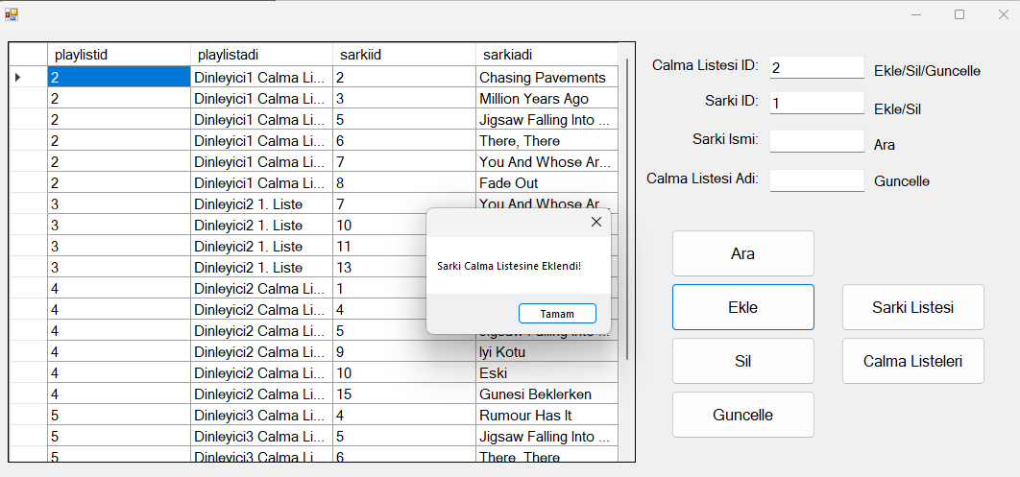

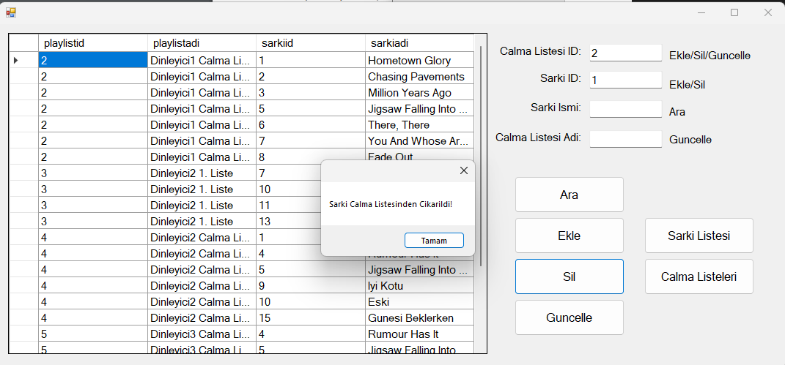

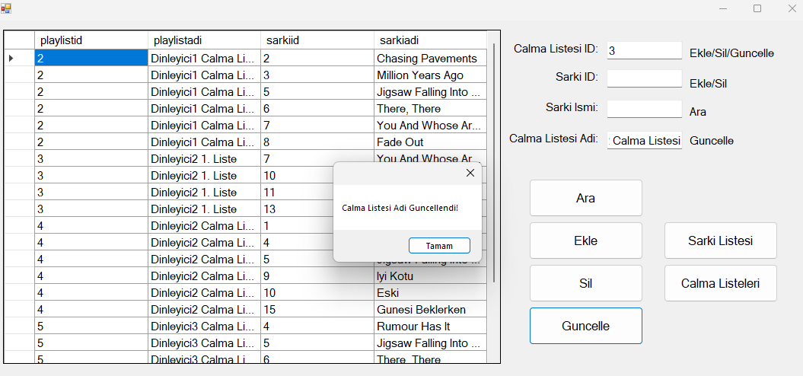

Kaynak kod/Uygulama: <https://drive.google.com/file/d/1FTbuDgsgggqGyfC7TCegV1wPkjeKn6_W/view?usp=sharing>

Umut Can ÇAĞATAY

G201210029 2C